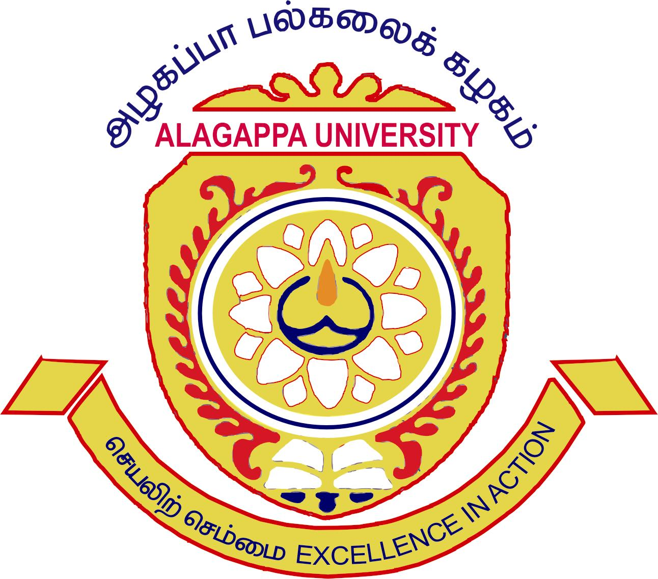
ALAGAPPA UNIVERSITY

[Accredited with A+ Grade by NAAC (CGPA:3.64) in the Third Cycle]

Guidelines for admission in Ph.D. programme for Foreign Nationals / NRIs

- Foreign candidates / NRIs should have passed Post Graduate degree or its equivalent.
- Provisional admission will be given to the foreign candidates / NRIs throughout the academic year.
- The provisionally selected foreign / NRI candidates should appear for the Entrance Test and Interview related to their Ph.D. programme to be conducted by the Department concerned, as per University norms.
- Admission will be confirmed, after completing entrance test and interview.
- This procedure will be adopted both for Full-time and Part-time candidates.
- US$10 or its equivalent Indian rupee will be charged for entrance test and interview.

